ATAL BIHARI VAJPAYEE GOVERNMENT INSTITUTE OF ENGINEERING AND TECHNOLOGY
PRAGATINAGAR DISTT. SHIMLA (H.P) – 171202 INDIA

COMPUTER SCIENCE AND ENGINEERING DEPARTMENT



Project Report on
Login System

(Computer Science & Engineering Department)

SUBMITTED BY: SUBMITTED TO:
Ashish Rangra Er.Navdeep Sharma
Rohit Chaudhary
Roll Numbers :
20010203012
20010203040
Branch: CSE
Semester: 5th
DECLARATION

--------------------------------------------------------------------------------

We Ashish Rangra & Rohit Chaudhary , students of Bachelor of Technology (B. Tech.) Computer Science & Engineering Department, Atal Bihari Vajpayee Government Institute of Engineering and Technology, Pragatinagar Shimla, session 2020-2024, hereby declare that the Internship report entitled "Login System", submitted to the Computer Science & Engineering Department, has been carried out by us under the guidance of Priyaanka Kumari at Solitaire Infosys on our one month training program. Special Thanks to Assistant Professor Navdeep Sharma and HOD Er. Anurag Sharma, Computer Science & Engineering Department, Atal Bihari Vajpayee Government Institute of Engineering and Technology, Pragatinagar Shimla for guidance. The "Login System" is an original piece of work and has not formed the basis for the award from any other college.

Date: ------ Ashish Rangra
Rohit Chaudhary
B.Tech (CSE) 5th Sem.

Department of Computer Science & Engineering
Atal Bihari Vajpayee Government Institute of Engineering and
Technology, Pragatinagar Distt. Shimla H.P-171202

CERTIFICATE
(Rohit Chaudhary)

--------------------------------------------------------------------------------
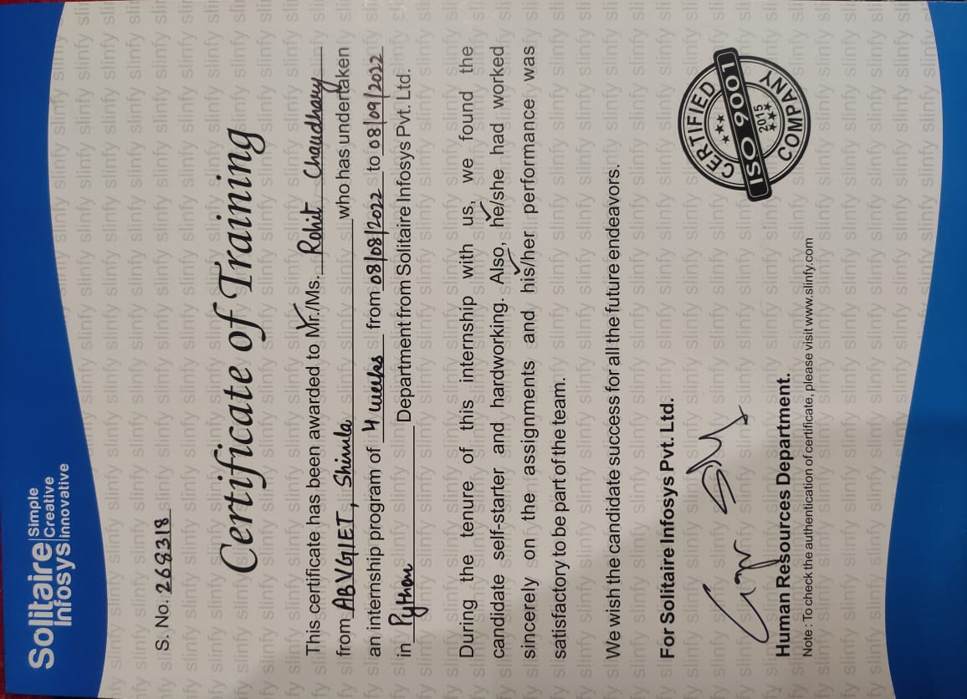

CERTIFICATE
(Ashish Rangra)

--------------------------------------------------------------------------------
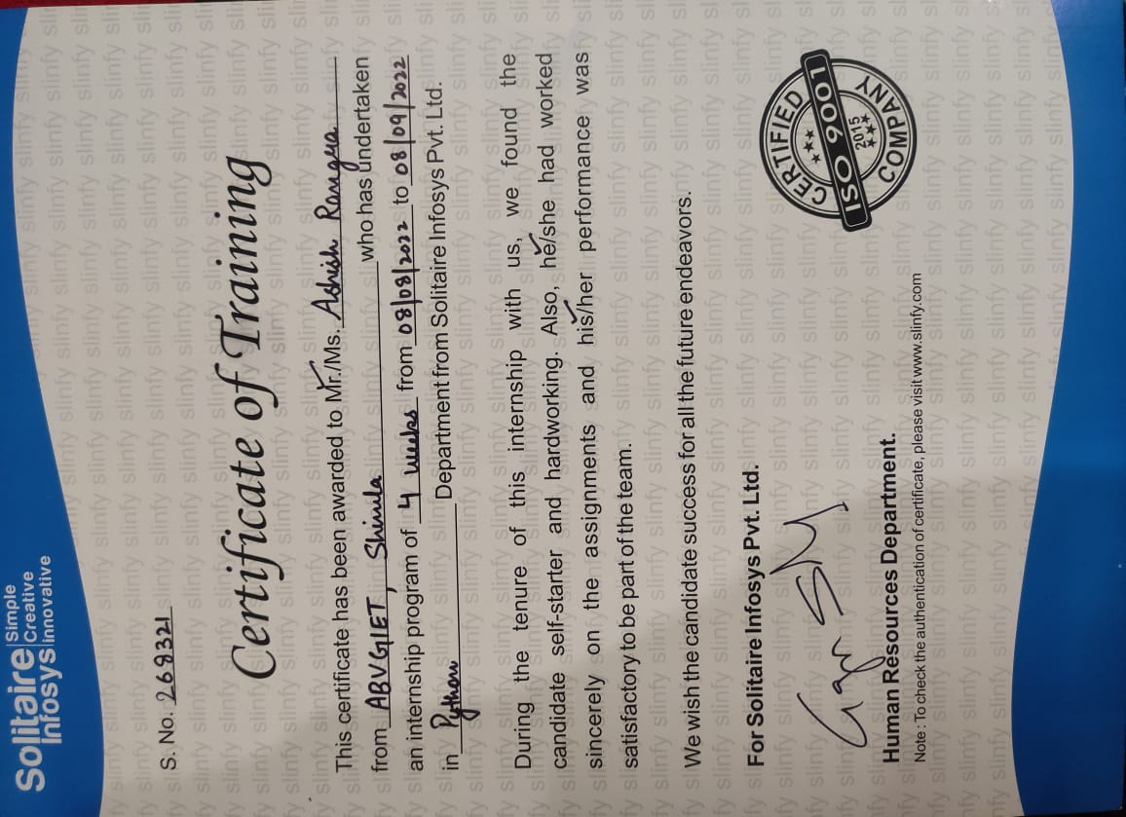

ACKNOWLEDGEMENT

--------------------------------------------------------------------------------

We would first like to thank our project advisor Er. Navdeep Sharma and HOD Er. Anurag Sharma Computer Science and Engineering department at ABVGIET, Priyaanka Kumari of the Solitaire Infosys Industrial Training Center at Mohali for the continuous support of our project, for their patience, motivation, enthusiasm, and immense knowledge. Their guidance helped us in all the time of development and writing of this project. We could not have imagined having a better advisor and mentor for my project work. They consistently allowed this project to be our own work, but steered us in the right direction whenever they thought we needed it.

Finally, We must express our very profound gratitude to our friends providing us with unfailing support and continuous encouragement throughout our years of study and through the process of researching and writing this project report. This accomplishment would not have been possible without them.

Thank you

Ashish Rangra
20010203012
Rohit Chaudhary
20010203040
B.Tech (CSE) 5th Sem.

ABSTRACT
The "Login Management System" has been developed to override the problems
prevailing in the practicing manual system. This software is supported to eliminate and in some cases reduce the hardships faced by this existing system. Moreover this system is designed for the particular need of the company to carry out operations in as smooth and effective manner. The application is reduced as much as possible to avoid errors while entering the data.
It also provides error message while entering invalid data. No formal knowledge is needed for the user to use this system. Thus by this all it proves it is user-friendly. Login Management System , as described above, can lead to error free, secure, reliable and fast management system. It can assist the user to concentrate on their other activities rather to concentrate on the record keeping. Thus it will help organization in better utilization of resources.
Every organization, whether big or small, has challenges to overcome and managing the informations of Password, Username, Changing Password, Groups, Permission and Authorization. Every Login Management System has different Username needs, therefore we design exclusive employee management systems that are adapted to your managerial requirements. This is designed to assist in strategic planning, and will help you ensure that your organization is equipped with the right level of information and details for your future goals. Also, for those busy executive who are always on the go, our systems come with remote access features, which will allow you to manage your workforce anytime, at all times. These systems will ultimately allow you to better
manage resources.

INDEX

Sr.No. | TITLE | PAGE NO
1 | Introduction of Project  Scope of Project  Python Language Introduction  History of Python  Python Features  Python graphical user interfaces (GUIs)  Tkinter Widgets  Geometry Management | 8-17
2. | Output | 18-19
3. | Conclusion | 20
4. | References | 21

Scope of the project Login Management System :

It may help collecting perfect management in details. In a very short time, the
collection will be obvious, simple and sensible. It will help a person to know the
management of passed year perfectly and vividly. It also helps in current all works relative to Login Management System. It will be also reduced the cost of collecting the management & collection procedure will go on smoothly.
Our project aims at Business process automation, i.e. we have tried to
computerize various processes of Login Management System.

- In computer system the person has to fill the various forms & number of copies of
the forms can be easily generated at a time.

- In computer system, it is not necessary to create the manifest but we can directly
print it, which saves our time.

- To assist the staff in capturing the effort spent on their respective working areas.

- To utilize resources in an efficient manner by increasing their productivity through
automation.

- The system generates types of information that can be used for various
purposes.

- It satisfy the user requirement

- Be easy to understand by the user and operator

- Be easy to operate

- Have a good user interface

- Be expandable

- Delivered on schedule within the budget.

Objective :
The main objective of the Project on Login Management System is to manage
the details of Username, Password, Email, Changing Password, Permission and
Authorization. It manages all the information about Username, Groups, Permission and Authorization, Username. The project is totally built at administrative end and thus only the administrator is guaranteed the access. The purpose of the project is to build an application program to reduce the manual work for managing the Username, Password, Groups, Email. It tracks all the details about the Email, Changing Password, Permission and Authorization.
Functionalities provided by Login Management System are as follows:

- Provides the searching facilities based on various factors. Such as Username,
- Email, Changing Password, Permission and Authorization

- Password details, Permission and Authorization details, Username.

- It tracks all the information of Password, Groups, Changing Password ect

- Manage the information of Password

- Shows the information and description of the Username, Email

- To increase efficiency of managing the Username, Password

- It deals with monitoring the information and transactions of Changing Password.

- Manage the information of Username

- Editing, adding and updating of Records is improved which results in proper
- resource management of Username data.

Need of the project :
The old manual system was suffering from a series of drawbacks. Since whole of the system was to be maintained with hands the process of keeping, maintaining and retrieving the information was very tedious and lengthy. The records were never used to be in a systematic order. there used to be lots of difficulties in associating any particular transaction with a particular context. If any information was to be found it was required to go through the different registers, documents there would never exist anything like report generation. There would always be unnecessary consumption of time while entering records and retrieving records. One more problem was that it was very difficult
to find errors while entering the records. Once the records were entered it was very difficult to update these records.
The reason behind it is that there is lot of information to be maintained and have
to be kept in mind while running the business .For this reason we have provided
features Present system is partially automated (computerized), actually existing system is quite laborious as one has to enter same information at three different places.
Following points should be well considered:

- Documents and reports that must be provided by the new system: there can also
- be few reports, which can help management in decision-making and cost
- controlling, but since these reports do not get required attention, such kind of
- reports and information were also identified and given required attention.

- Details of the information needed for each document and report.

- The required frequency and distribution for each document.

- Probable sources of information for each document and report.

- With the implementation of computerized system, the task of keeping records in
- an organized manner will be solved. The greatest of all is the retrieval of information, which will be at the click of the mouse. So the proposed system helps in saving the time in different operations and making information flow easy giving
- valuable reports

PYTHON:

Python Language Introduction :
Python is a widely used general-purpose, high level programming language. It was initially designed by Guido van Rossum in 1991 and developed by Python Software Foundation. It was mainly developed for emphasis on code readability, and its syntax allows programmers to express concepts in fewer lines of code.
Python is a programming language that lets you work quickly and integrate systems more efficiently.
Python is a high-level, interpreted, interactive and object-oriented scripting language. Python is designed to be highly readable. It uses English keywords frequently where as other languages use punctuation, and it has fewer syntactical constructions than other languages.
- Python is Interpreted − Python is processed at runtime by the interpreter. You do not need to compile your program before executing it. This is similar to PERL and PHP.
- Python is Interactive − You can actually sit at a Python prompt and interact with the interpreter directly to write your programs.
- Python is Object-Oriented − Python supports Object-Oriented style or technique of programming that encapsulates code within objects.
- Python is a Beginner's Language − Python is a great language for the beginner-level programmers and supports the development of a wide range of applications from simple text processing to WWW browsers to games.

History of Python :
Python was developed by Guido van Rossum in the late eighties and early nineties at the National Research Institute for Mathematics and Computer Science in the Netherlands.
Python is derived from many other languages, including ABC, Modula-3, C, C++, Algol-68, SmallTalk, and Unix shell and other scripting languages.
Python is copyrighted. Like Perl, Python source code is now available under the GNU General Public License (GPL).
Python is now maintained by a core development team at the institute, although Guido van Rossum still holds a vital role in directing its progress.

Python Features :
Python's features include −
- Easy-to-learn − Python has few keywords, simple structure, and a clearly defined syntax. This allows the student to pick up the language quickly.
- Easy-to-read − Python code is more clearly defined and visible to the eyes.
- Easy-to-maintain − Python's source code is fairly easy-to-maintain.
- A broad standard library − Python's bulk of the library is very portable and cross-platform compatible on UNIX, Windows, and Macintosh.
- Interactive Mode − Python has support for an interactive mode which allows interactive testing and debugging of snippets of code.
- Portable − Python can run on a wide variety of hardware platforms and has the same interface on all platforms.
- Extendable − You can add low-level modules to the Python interpreter. These modules enable programmers to add to or customize their tools to be more efficient.
- Databases − Python provides interfaces to all major commercial databases.
- GUI Programming − Python supports GUI applications that can be created and ported to many system calls, libraries and windows systems, such as Windows MFC, Macintosh, and the X Window system of Unix.
- Scalable − Python provides a better structure and support for large programs than shell scripting.
Apart from the above-mentioned features, Python has a big list of good features, few are listed below −
- It supports functional and structured programming methods as well as OOP.
- It can be used as a scripting language or can be compiled to byte-code for building large applications.
- It provides very high-level dynamic data types and supports dynamic type checking.
- IT supports automatic garbage collection.
- It can be easily integrated with C, C++, COM, ActiveX, CORBA, and Java.

Python graphical user interfaces (GUIs) :
- Tkinter − Tkinter is the Python interface to the Tk GUI toolkit shipped with Python. We would look this option in this chapter.
- wxPython − This is an open-source Python interface for wxWindows http://wxpython.org.
- JPython − JPython is a Python port for Java which gives Python scripts seamless access to Java class libraries on the local machine http://www.jython.org.
There are many other interfaces available, which you can find them on the net.

PYTHON TKINTER GUI :
Tkinter Programming


Tkinter is the standard GUI library for Python. Python when combined with Tkinter provides a fast and easy way to create GUI applications. Tkinter provides a powerful object-oriented interface to the Tk GUI toolkit.
Creating a GUI application using Tkinter is an easy task. All you need to do is perform the following steps −
- Import the Tkinter module.
- Create the GUI application main window.
- Add one or more of the above-mentioned widgets to the GUI application.
- Enter the main event loop to take action against each event triggered by the user.
Example:
import tkinter
top = tkinter.Tk()
# Code to add widgets will go here...
top.mainloop()
This would create a following window −
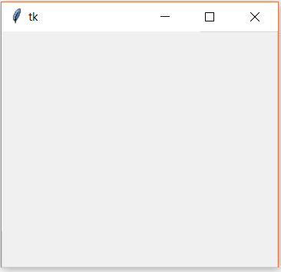

Tkinter Widgets :
Tkinter provides various controls, such as buttons, labels and text boxes used in a GUI application. These controls are commonly called widgets.
There are currently 15 types of widgets in Tkinter. We present these widgets as well as a brief description in the following table –
Sr.No. | Operator & Description
1 | Button  The Button widget is used to display buttons in your application.
2 | Canvas  The Canvas widget is used to draw shapes, such as lines, ovals, polygons and rectangles, in your application.
3 | Checkbutton  The Checkbutton widget is used to display a number of options as checkboxes. The user can select multiple options at a time.
4 | Entry  The Entry widget is used to display a single-line text field for accepting values from a user.
5 | Frame  The Frame widget is used as a container widget to organize other widgets.
6 | Label  The Label widget is used to provide a single-line caption for other widgets. It can also contain images.
7 | Listbox  The Listbox widget is used to provide a list of options to a user.
8 | Menubutton  The Menubutton widget is used to display menus in your application.
9 | Menu  The Menu widget is used to provide various commands to a user. These commands are contained inside Menubutton.
10 | Message  The Message widget is used to display multiline text fields for accepting values from a user.
11 | Radiobutton  The Radiobutton widget is used to display a number of options as radio buttons. The user can select only one option at a time.
12 | Scale  The Scale widget is used to provide a slider widget.
13 | Scrollbar  The Scrollbar widget is used to add scrolling capability to various widgets, such as list boxes.
14 | Text  The Text widget is used to display text in multiple lines.
15 | Toplevel  The Toplevel widget is used to provide a separate window container.
16 | Spinbox  The Spinbox widget is a variant of the standard Tkinter Entry widget, which can be used to select from a fixed number of values.
17 | PanedWindow  A PanedWindow is a container widget that may contain any number of panes, arranged horizontally or vertically.
18 | LabelFrame  A labelframe is a simple container widget. Its primary purpose is to act as a spacer or container for complex window layouts.
19 | tkMessageBox  This module is used to display message boxes in your applications.

Geometry Management :
All Tkinter widgets have access to specific geometry management methods, which have the purpose of organizing widgets throughout the parent widget area. Tkinter exposes the following geometry manager classes: pack, grid, and place.
- The pack() Method − This geometry manager organizes widgets in blocks before placing them in the parent widget.
- The grid() Method − This geometry manager organizes widgets in a table-like structure in the parent widget.
- The place() Method − This geometry manager organizes widgets by placing them in a specific position in the parent widget.

Software Requirement Specification:
The Software Requirements Specification is produced at the culmination of the
analysis task. The function and performance allocated to software as part of system engineering are refined by establishing a complete information description, a detailed functional and behavioural description, an indication of performance requirements and design constraints, appropriate validation criteria, and other data pertinent to requirements.
The proposed system has the following requirements:

- System needs store information about new entry of Username.

- System needs to help the internal staff to keep information of Password and find
- them as per various queries.

- System need to maintain quantity record.

- System need to keep the record of Email.

- System need to update and delete the record.

- System also needs a search area.

- It also needs a security system to prevent data.

Expected Output: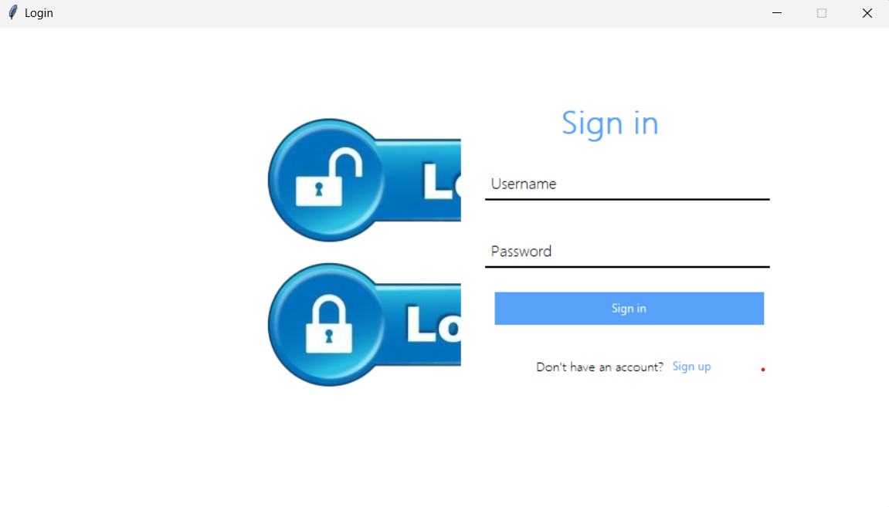
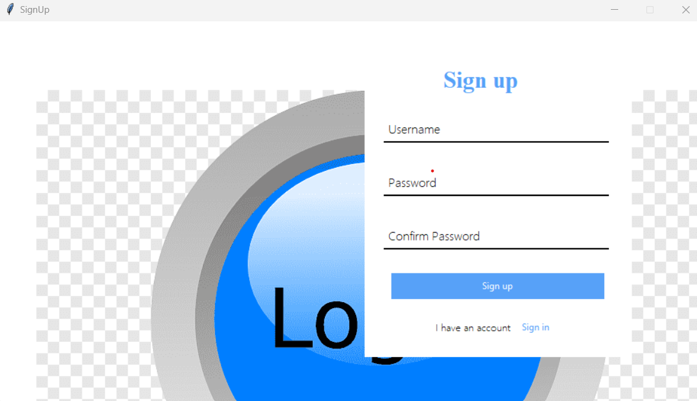

Conclusion of the Project Login Management System:

Our project is only a humble venture to satisfy the needs to manage their project
work. Several user friendly coding have also adopted. This package shall prove to be a powerful package in satisfying all the requirements of the school. The objective of software planning is to provide a frame work that enables the manger to make reasonable estimates made within a limited time frame at the beginning of the software project and should be updated regularly as the project progresses.
At the end it is concluded that we have made effort on following points...

A description of the background and context of the project and its relation to work already done in the area.

Made statement of the aims and objectives of the project.

The description of Purpose, Scope, and applicability.

We define the problem on which we are working in the project.

We describe the requirement Specifications of the system and the actions that
can be done on these things.

We understand the problem domain and produce a model of the system, which
describes operations that can be performed on the system.

We included features and operations in detail, including screen layouts.

We designed user interface and security issues related to system.

References and Bibliography :

Google for problem solving

http://www.javaworld.com/javaworld/jw-01-1998/jw-01-Credentialreview.html

Database Programming with JDBC and Java by O'Reilly

Head First Java 2nd Edition

http://www.jdbc-tutorial.com/

Java and Software Design Concepts by Apress

https://www.tutorialspoint.com/java/

http://www.javatpoint.com/java-tutorial

https://docs.oracle.com/javase/tutorial/

http://www.wampserver.com/en/

http://www.JSP.net/

http://www.tutorialspoint.com

